**Safety Systems in Strollers**

1. **Restraints**

* Harnesses to keep child inside the seat
* Eliminates risk of child falling out/being knocked out of carrier/seat
* Examples include both harnesses and seat belts
* 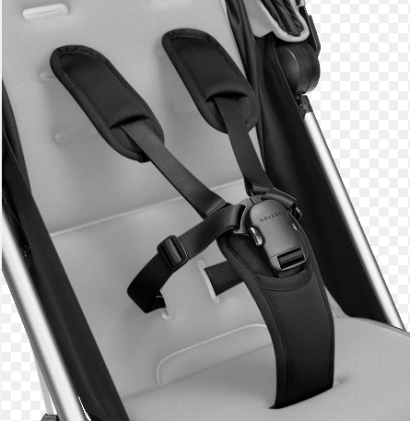

1. **Brakes**

* Stroller brakes prevent it from moving when not in use/when not being handled
* Prevents stroller from rolling away or moving unintentionally
* Mainly “parking breaks”
* 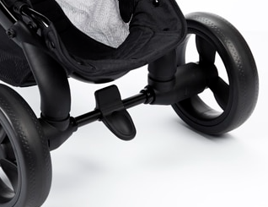
* Active brakes do exist, mainly for jogging strollers
* 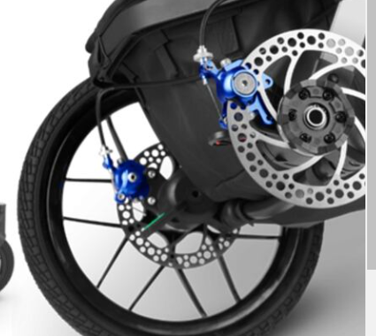
  + Kinda dangerous, these got recalled for slicing children’s hands open
    - https://www.kalb.com/2022/09/04/baby-strollers-recalled-due-potential-injury-childrens-fingers/
  + Drum Brake over discs

1. **Wheels/Stability**

* Like cars
* Bigger, thicker wheels are better for stability
  + Less likely for tips
* Also easier to control in rougher terrain
  + Better grip, more area to cover bumps/holes
* Frame must also be stable
  + Low center of gravity
  + Low flexibility

1. **Leg Enclosure**

* All strollers must be supporting the legs, regardless of age
* Prevents child from slipping down out of the stroller
* Also must support child like a comfortable suspension
  + When going over bumps and such
* For babies, it is optimal to be lying down or mostly
  + Best for growth and health
* With a seat, footrest is mandatory
* 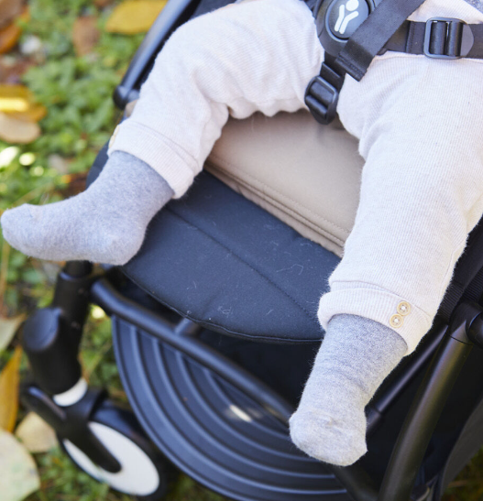

1. **Canopy**

* Covers the child in the stroller
* Protects against weather
  + Heat, rain, hail, wind, etc.
* Also protects against some flying debris and possible falls/spills
* Mandatory
* 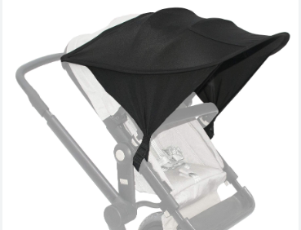

**Sources:**

* <https://www.consumerreports.org/babies-kids/strollers/important-stroller-safety-features-to-look-for-a2549523505/?srsltid=AfmBOoq7qetURyfzJFMmgMp_MnQfFh3KY8TD8gSkiSpKphUDVAbQ1gut>
* <https://www.canada.ca/en/health-canada/services/infant-care/strollers-carriages.html>
* <https://kidshealth.org/en/parents/products-strollers.html#:~:text=The%20safest%20design%20is%20a,used%20in%20the%20reclined%20position>.